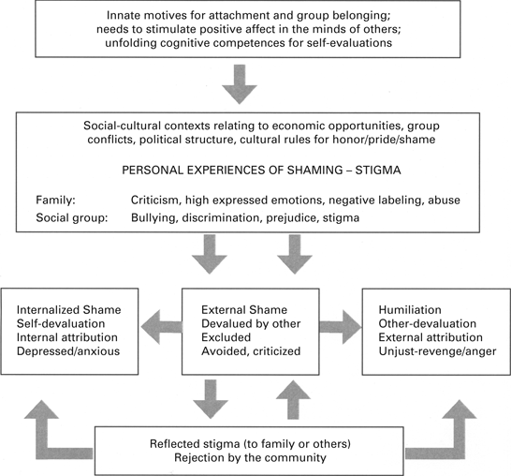

Adapted from Gilbert (2002) ‘An Evolutionary and Biopsychosocial model of shame’.